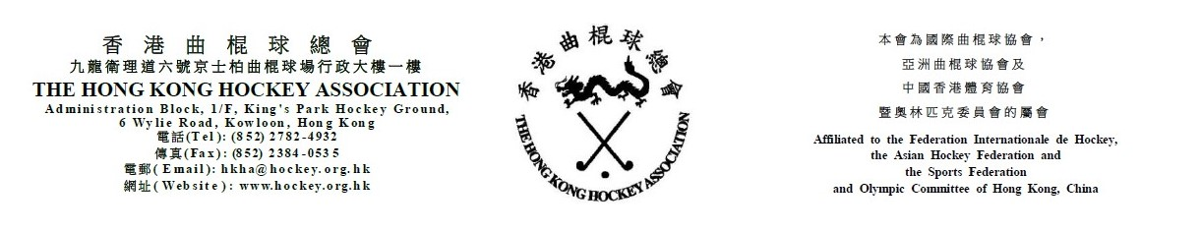

Attendance Form for
The Hong Kong Hockey Association
Extraordinary General Meeting
on Friday 11 June 2021

(Please see notes below before completing the form)
The following is authorized to represent __________________________________ (Member Club) and to vote at the HKHA EGM on Friday 11 June 2021.

_____________________________________
(Name)
Note: Owing to the COVID-19 pandemic situation, only one representative from each club is invited to attend the HKHA EGM.

(Name of Club Official) |  | (Signature of Club Official)

(Position of Club Official) |  |  | (Date)

Notes: (1) Club officials include President, Chairman, Hon. Secretary, Convenor and Hockey Section Captain.
- This form must be received by the HKHA office no later than 5:00 pm on 4 June 2021.

